**AWS CLOUD PRACTITIONER**

**Section 10: Deployments & Managing Infrastructure at Scale:**

1. **CloudFormation Overview:**

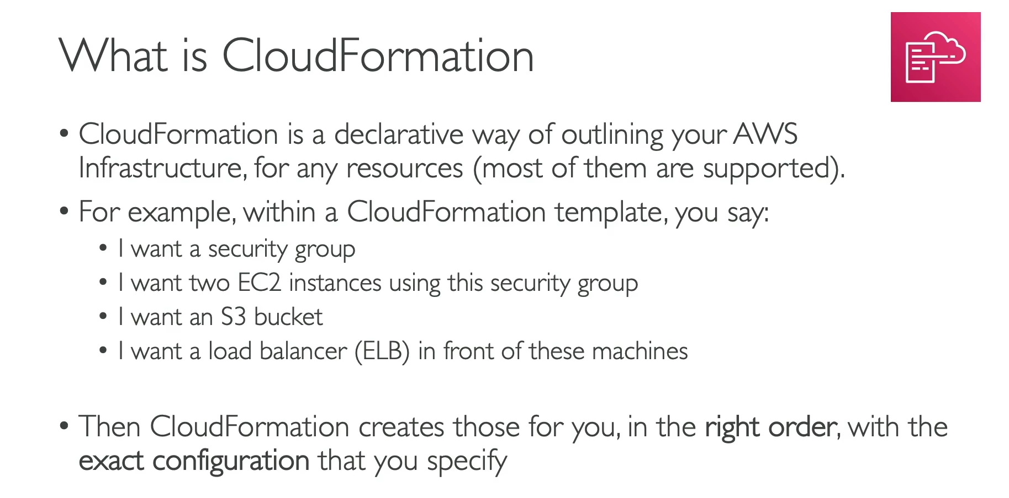

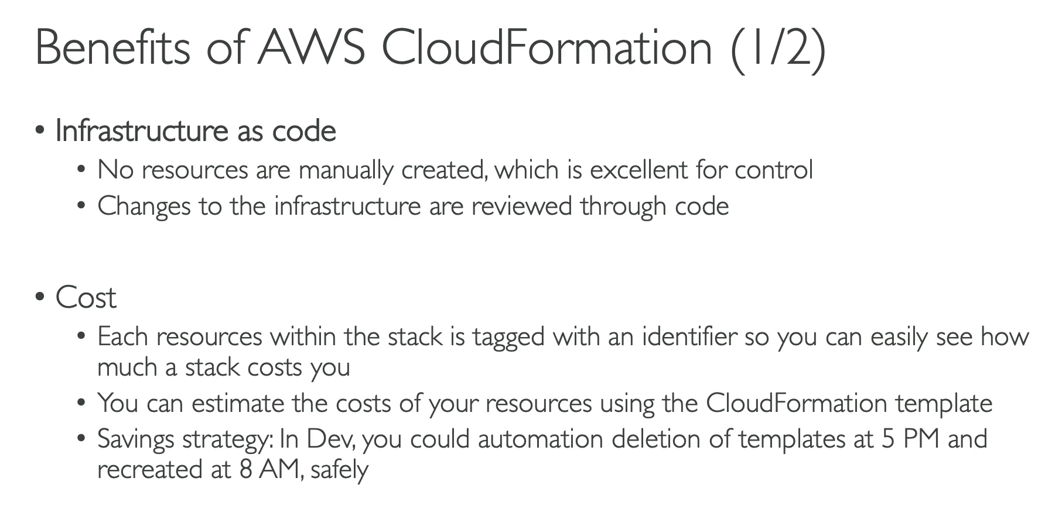

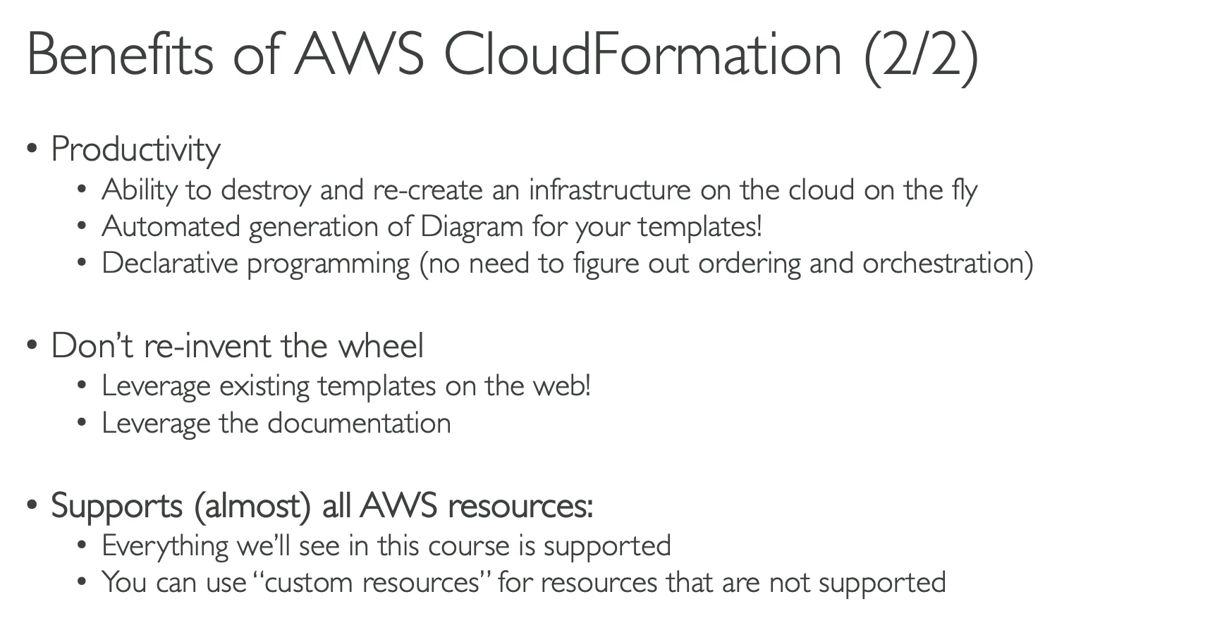

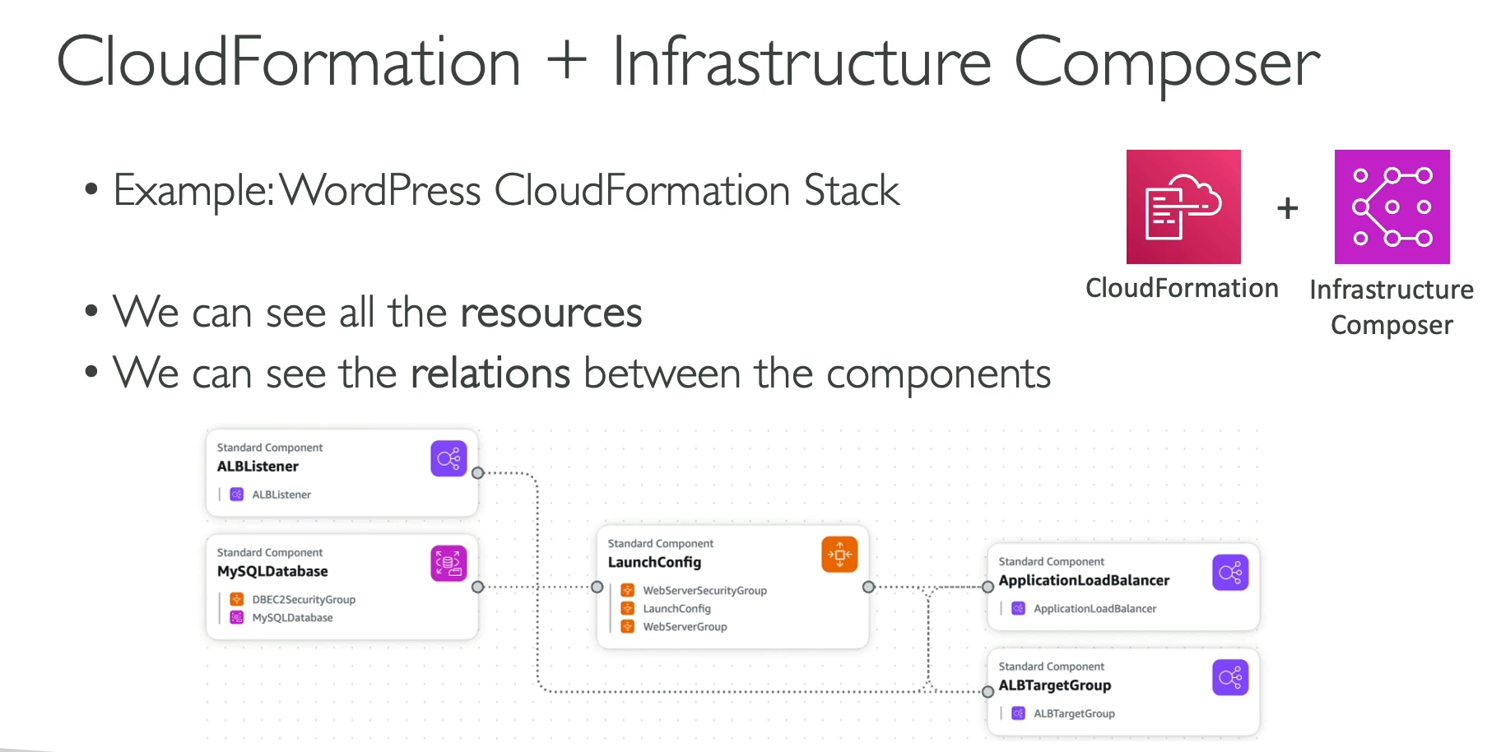

CloudFormation is a foundational AWS service that allows you to manage and provision your cloud infrastructure in a **declarative way** using code. You define the desired state of your resources, and CloudFormation handles the creation, configuration, and dependencies for you.

**Key Principles and Benefits**

* **Infrastructure as Code (IaC):** 💻 CloudFormation allows you to define your AWS infrastructure in a template (code file), moving away from manual, one-off resource creation. This provides version control, reviewable changes, and repeatable deployments.
* **Automation and Productivity:** You can easily **destroy and recreate entire environments** on demand. CloudFormation intelligently determines the correct order of resource creation, saving you from manual dependency management.
* **Cost Management:** 💲 CloudFormation helps with cost control. All resources created by a template are automatically **tagged**, making it easy to track and attribute costs. You can also automate the shutdown of environments during off-hours to save money.
* **Reusability:** You can create and share templates to **replicate complex architectures** across different environments (e.g., development, staging, production), regions, or even different AWS accounts.
* **Diagram Generation:** The AWS console's **Infrastructure Composer service** can generate a visual diagram of your stack, showing the resources and their relationships. This is great for understanding and documenting your architecture.
* **Comprehensive Support:** CloudFormation supports almost all AWS resources. If a resource isn't natively supported, you can use **custom resources** to extend its functionality.

**When to Use CloudFormation**

CloudFormation is the go-to service for:

* Building a **repeatable architecture** in multiple regions or accounts.
* Enforcing a standardized **Infrastructure as Code** approach across your organization.
* Automating the **creation and deletion of entire environments** for development and testing.
* Providing a **centralized way** to manage and monitor your entire infrastructure stack.

1. **CloudFormation Hands On:**

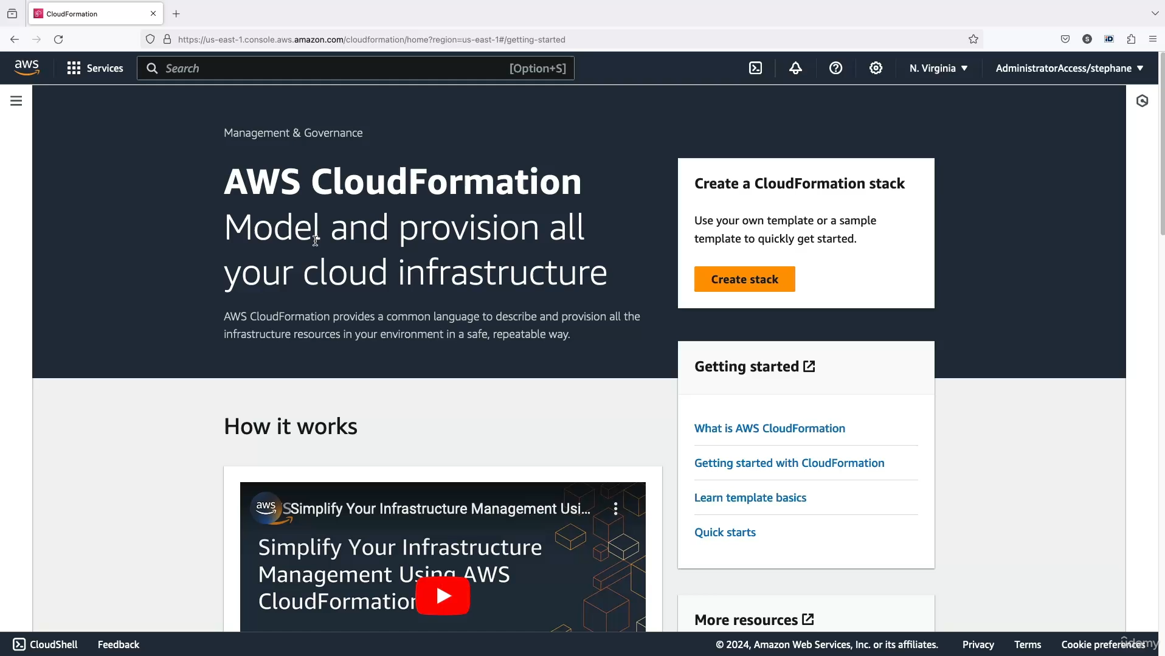

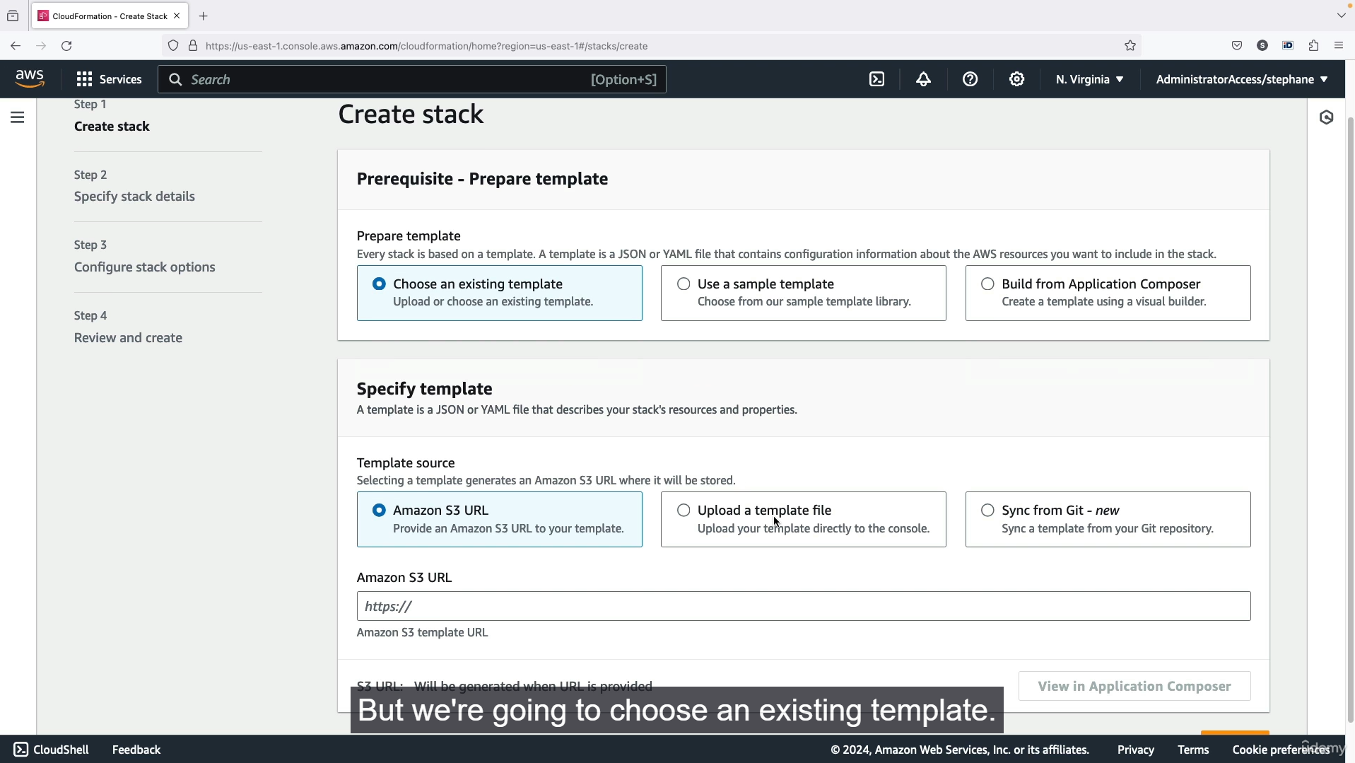

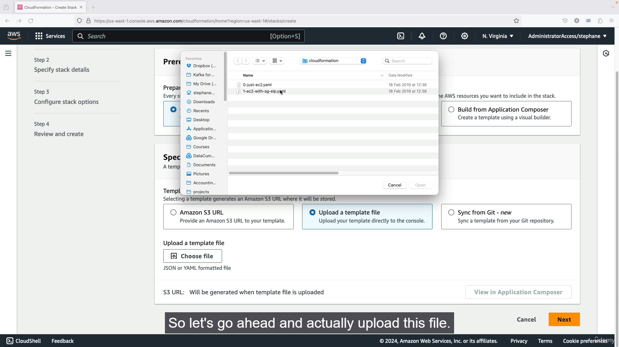

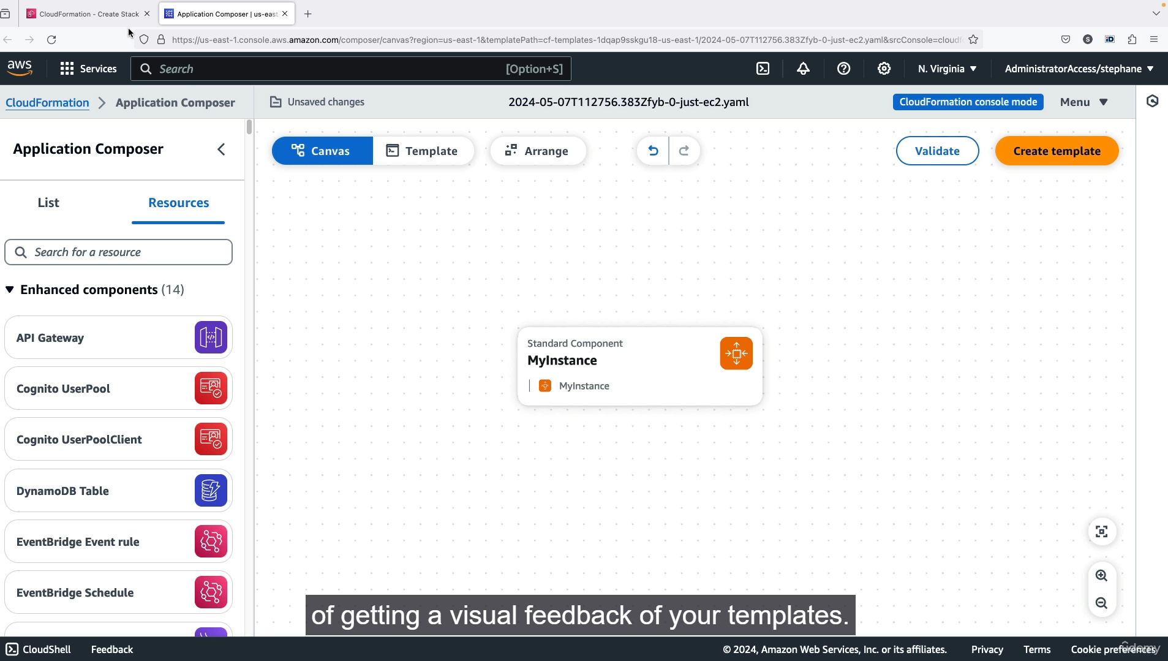

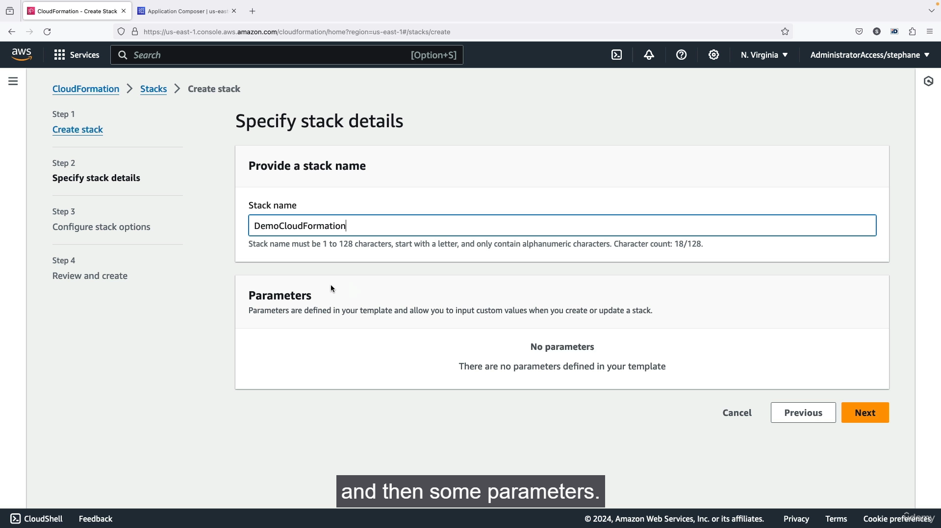

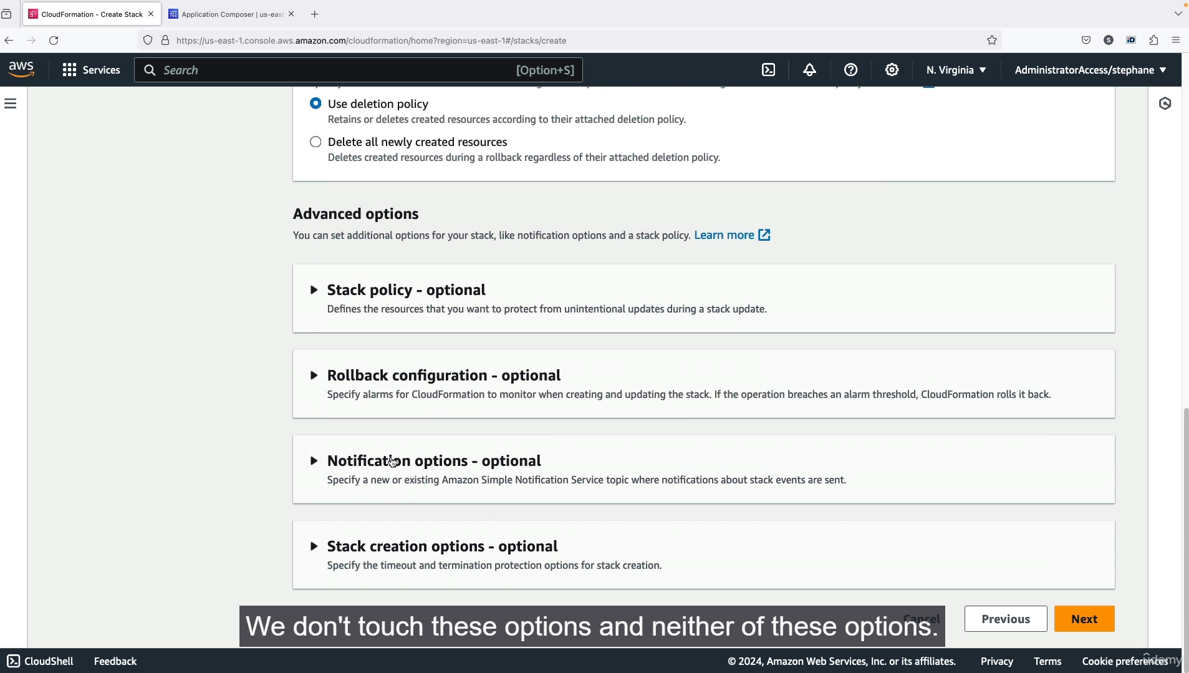

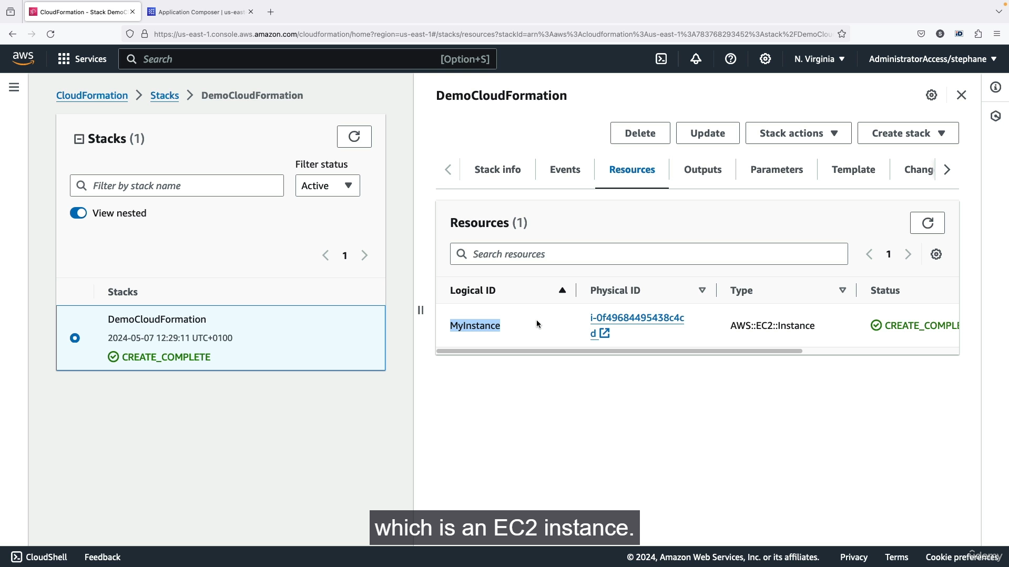

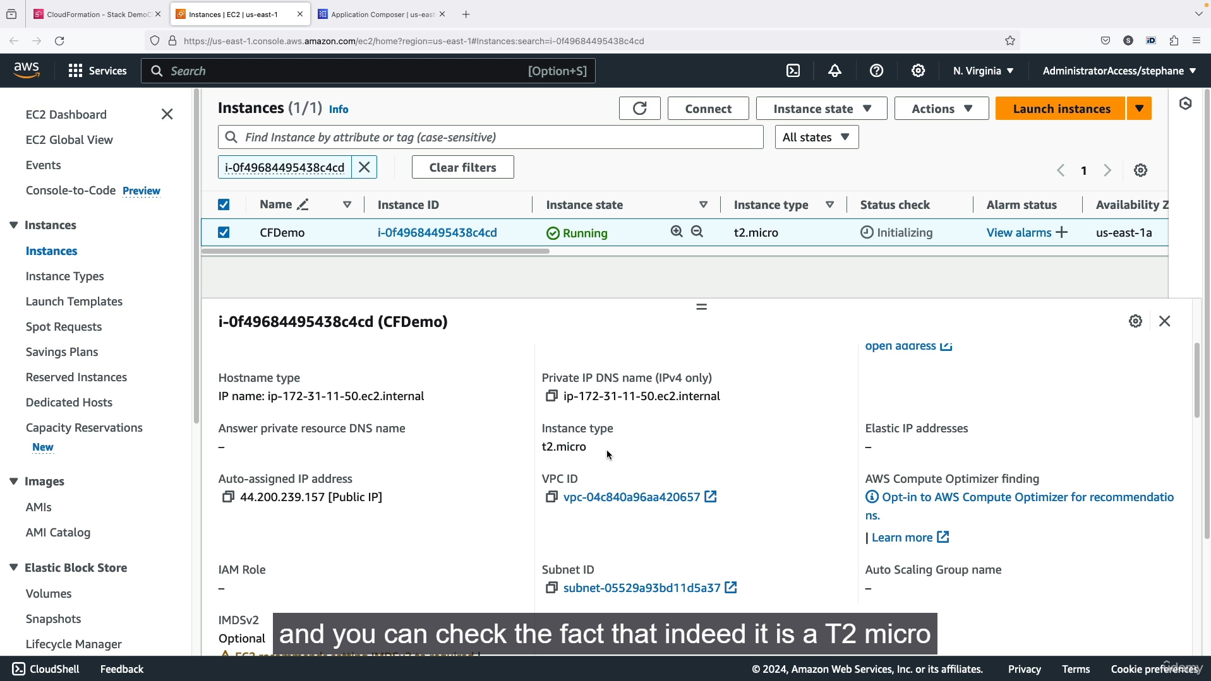

This guide outlines a step-by-step process for using AWS CloudFormation to create and update infrastructure as code.

**1. Initial Stack Creation**

1. **Select Region:** Ensure you're in the **US East (N. Virginia) us-east-1** region, as the provided template is configured for it.
2. **Create Stack:** In the CloudFormation console, click "Create stack."
3. **Upload Template:** Choose the **"Upload a template file"** option and select the 0-just-EC2.yaml file. This file defines a single EC2 instance with specific properties (US East 1a Availability Zone, a specific AMI ID, and T2 micro instance type).
4. **Review and Configure:**
   * Click "Next."
   * Provide a stack name (e.g., demo-CloudFormation).
   * Add a tag (e.g., Key: Name, Value: CFDemo).
   * Click "Next" and then "Submit" to create the stack.
5. **Verification:**
   * CloudFormation will create an EC2 instance based on the YAML file.
   * Check the **Events** tab to monitor the creation process.
   * Go to the EC2 console to verify the new instance is running with the correct configurations (T2 micro, specified AMI ID) and tags.

**2. Updating the Stack**

1. **Initiate Update:** In the CloudFormation console, select your stack and click "Update."
2. **Replace Template:** Choose the **"Replace current template"** option.
3. **Upload New Template:** Upload the 1-ec2-with-sg-eip.yaml file. This updated template includes parameters, an Elastic IP (EIP), and two security groups.
4. **Configure Parameters:** Enter a value for the **"Security group description"** parameter (e.g., demo description).
5. **Review Changeset:** Click "Next." CloudFormation will generate a **Changeset**, which shows the planned modifications.
   * The changeset will indicate that new resources will be added (Elastic IP, two security groups).
   * It will also show that the original EC2 instance will be replaced (deleted and a new one created). This is a crucial point to note.
6. **Submit Update:** Click "Submit" to apply the changes.
7. **Verification:**
   * Monitor the **Events** tab to see the update process. CloudFormation intelligently creates the new security groups and Elastic IP first.
   * A new EC2 instance will be created, and the old one will be terminated.
   * In the EC2 console, you'll see the new instance running.
   * Check the Elastic IP and Security Groups services to confirm the new resources have been created and correctly linked to the new instance.

**3. Deleting the Stack**

1. **Select Stack:** In the CloudFormation console, select your stack.
2. **Delete:** Click the "Delete" button.
3. **Confirm:** CloudFormation will handle the deletion of all associated resources in the correct order, ensuring a complete cleanup. You should not manually delete resources created by CloudFormation.

**Summary of CloudFormation Principles:**

* **Infrastructure as Code:** Defines your AWS resources in a declarative template (YAML or JSON).
* **Declarative:** You state the desired end state, and CloudFormation figures out the steps to achieve it.
* **Intelligent Updates:** CloudFormation analyzes templates to create a **Changeset**, showing exactly what will be modified, added, or deleted before execution.
* **Automatic Cleanup:** Deleting a stack removes all resources created by it, ensuring no lingering resources or costs.
* **Application Composer:** Provides a visual representation of your template, which is useful for understanding the architecture.

1. **CDK Overview:**

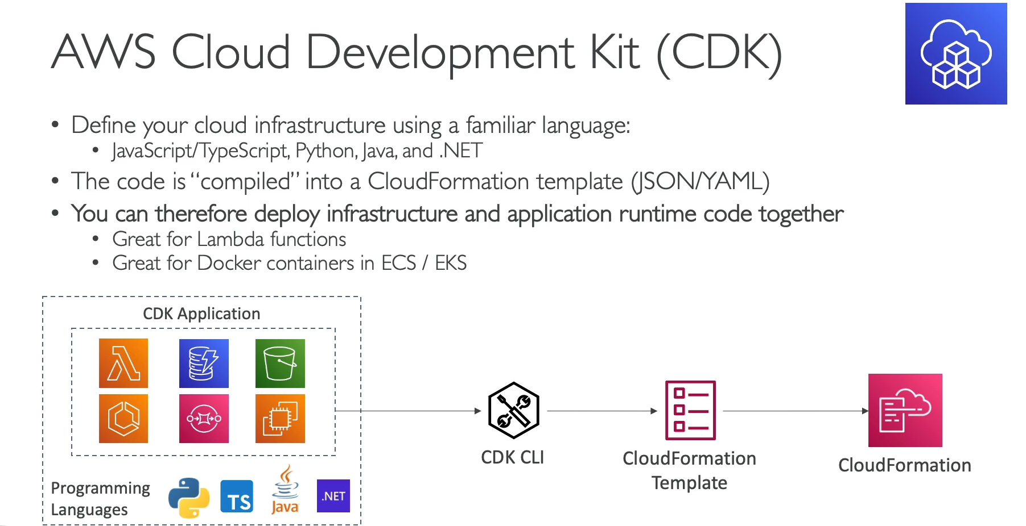

The **AWS Cloud Development Kit (CDK)** is an open-source framework that lets you define your cloud infrastructure using familiar programming languages instead of writing CloudFormation templates directly in JSON or YAML.

**Key Principles and Benefits**

* **Infrastructure as Code with Your Favorite Language:** The CDK allows you to use languages you're already comfortable with, such as **Python, JavaScript, TypeScript, Java, C#, or Go**, to define your AWS resources.
* **Abstraction and Productivity:** The CDK provides **constructs**, which are high-level, reusable components that abstract away the complexities of low-level CloudFormation resources. This means you can define an entire application or a set of resources with just a few lines of code. For example, a single construct can define a Fargate service, its load balancer, and all the necessary networking components.
* **Compilation to CloudFormation:** Your CDK code is not deployed directly to AWS. Instead, the **CDK CLI** compiles your code into a standard CloudFormation template (JSON or YAML), which is then used to deploy your resources to AWS.
* **Leverage Programming Language Features:** Using a familiar programming language gives you access to powerful features not available in YAML or JSON, such as:
  + **Logic and Loops:** You can use loops to create multiple similar resources, such as a dozen S3 buckets or a specific number of EC2 instances.
  + **Functions and Reusability:** You can create functions and methods to define common infrastructure patterns and reuse them across different projects.
  + **IDE Support and Type Safety:** You get all the benefits of your Integrated Development Environment (IDE), including auto-completion, syntax highlighting, and **type safety** (catching errors before deployment).
* **Unified Development:** The CDK allows you to define your application code (e.g., a Lambda function) and the infrastructure to support it in the **same programming language and project**. This simplifies development, especially for serverless and containerized applications.

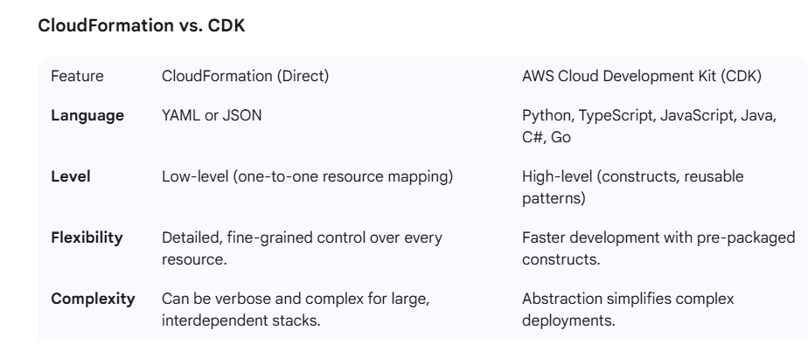

1. **Beanstalk Overview:**

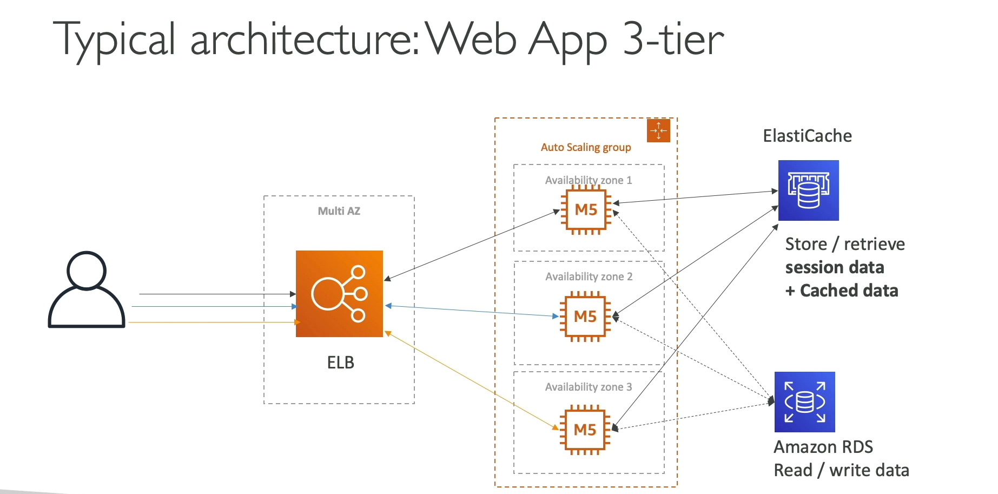

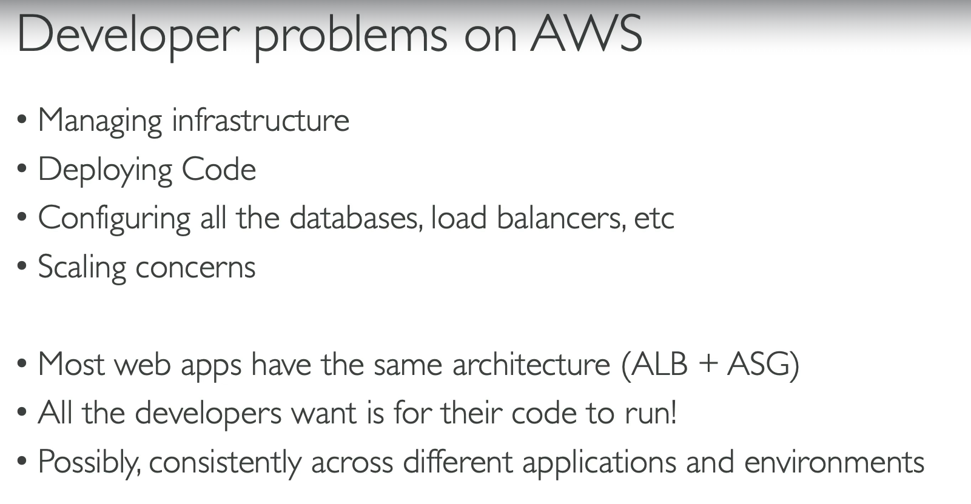

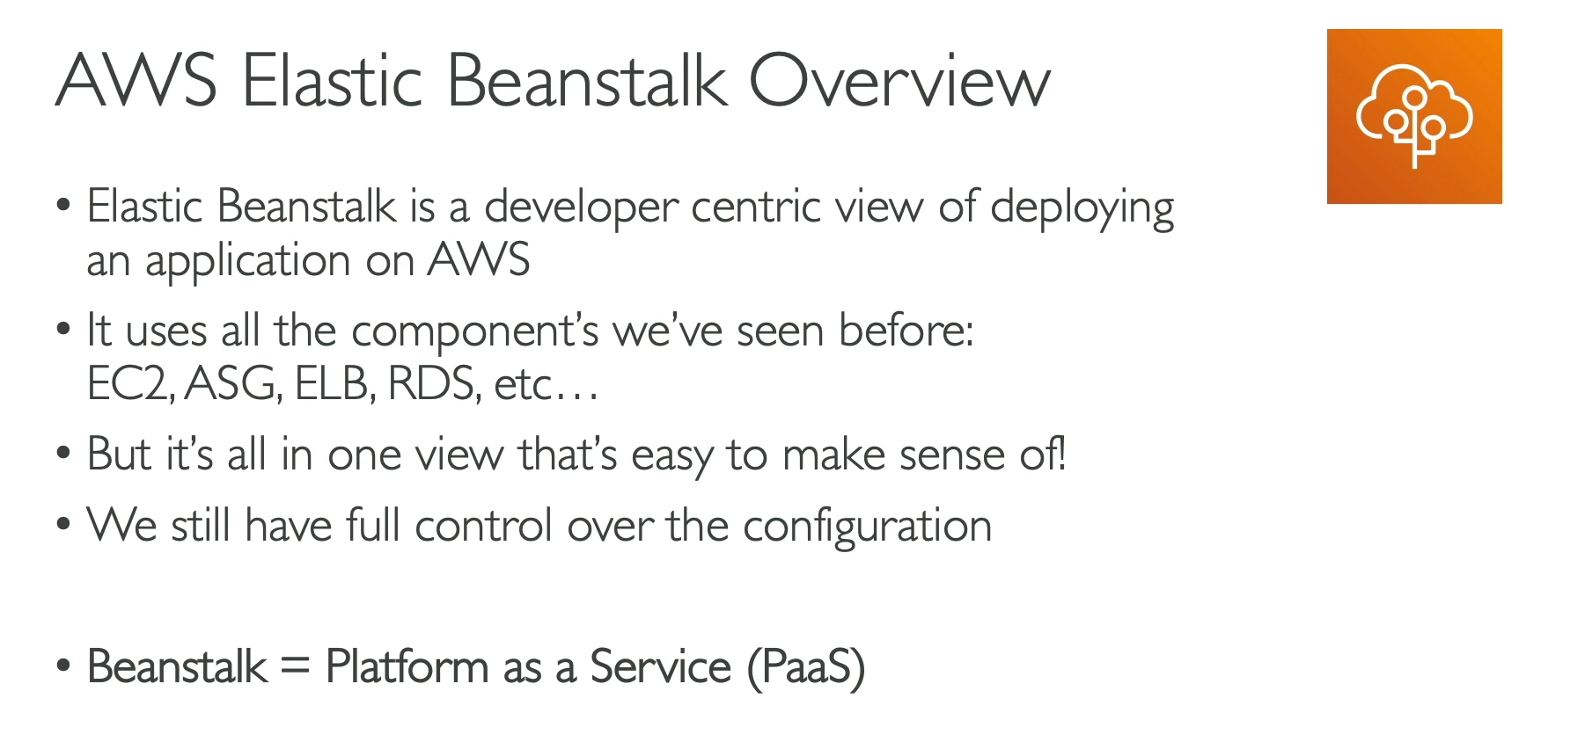

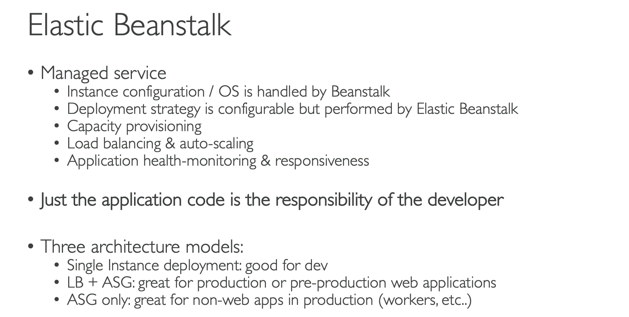

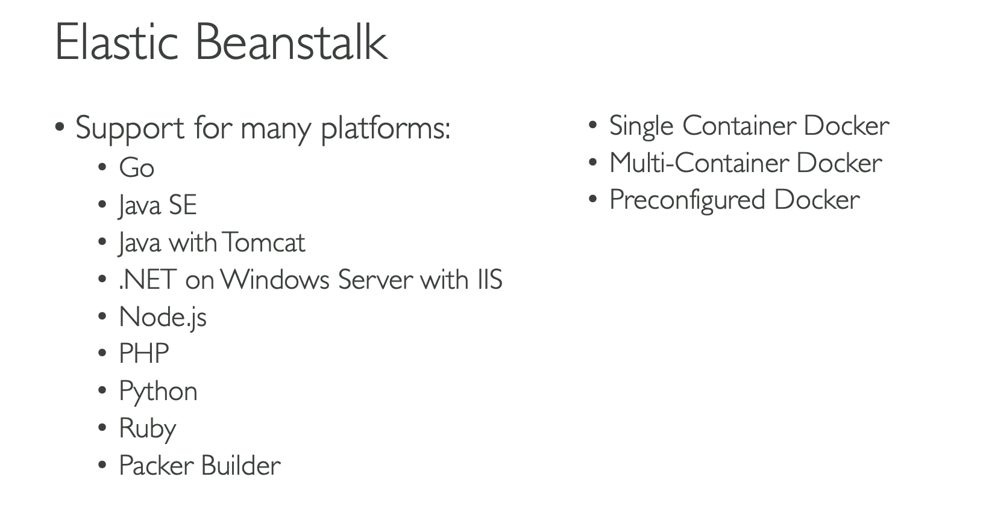

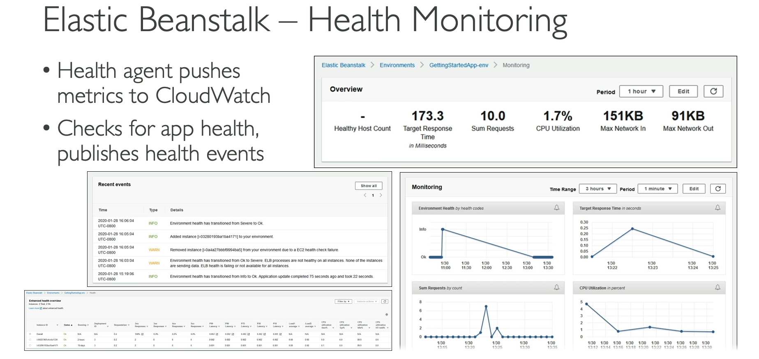

Elastic Beanstalk is a **Platform as a Service (PaaS)** that provides a developer-friendly way to deploy and scale web applications and services. It automates the provisioning of underlying infrastructure, allowing developers to focus solely on their code.

**Key Principles and Benefits**

* **Developer-Centric Focus:** Beanstalk is designed for developers who want to deploy code without managing the underlying infrastructure. You simply upload your application code, and Beanstalk handles the rest.
* **Managed Service:** Beanstalk is a managed service that provisions and manages the key components of a web application's infrastructure, including:
  + **EC2 Instances:** Provisioning and configuration.
  + **Auto Scaling Group (ASG):** Automatic scaling based on traffic.
  + **Elastic Load Balancer (ELB):** Distributes incoming traffic.
  + **RDS Database:** Can be automatically provisioned and managed (optional).
  + **ElastiCache:** Can be provisioned for in-memory caching (optional).
* **Cost:** Elastic Beanstalk itself is **free to use**. You only pay for the underlying AWS resources (EC2 instances, S3 storage, etc.) that are provisioned to run your application.
* **Simple Deployment:** Beanstalk simplifies the entire deployment process. It manages all the necessary steps, from capacity provisioning and load balancing to application health monitoring.
* **Underlying Architecture:** While Beanstalk provides a simplified interface, it's not a new service; it's an orchestration layer that automates the deployment of the same foundational AWS services (EC2, ASG, ELB, etc.) you would use to build a traditional 3-tier architecture.
* **Platform Support:** Beanstalk supports a wide range of platforms and languages, including **Docker**, Node.js, Python, Java, Ruby, PHP, Go, and .NET.
* **Health Monitoring:** Beanstalk includes built-in application health monitoring. A health agent on each EC2 instance pushes metrics to CloudWatch, and the Beanstalk dashboard provides a comprehensive view of your application's health and events.
* **Architecture Models:** Beanstalk supports different deployment models based on your needs:
  + **Single Instance Deployment:** Ideal for development and testing environments.
  + **Load-Balanced + Auto Scaling Group:** The most common model for production environments, providing high availability and scalability.
  + **Worker Environment:** Designed for non-web applications or background tasks, using a standalone ASG.

**When to Use Beanstalk**

* You are a developer and want a quick and easy way to deploy a web application without configuring individual AWS resources.
* You need to deploy a repeatable application architecture for different environments (e.g., development, staging, production).
* You want to leverage a platform as a service (PaaS) to abstract away infrastructure management.
* You are deploying an application using a common language or framework and want built-in support for scaling, load balancing, and health monitoring.

1. **Beanstalk Hands On:**

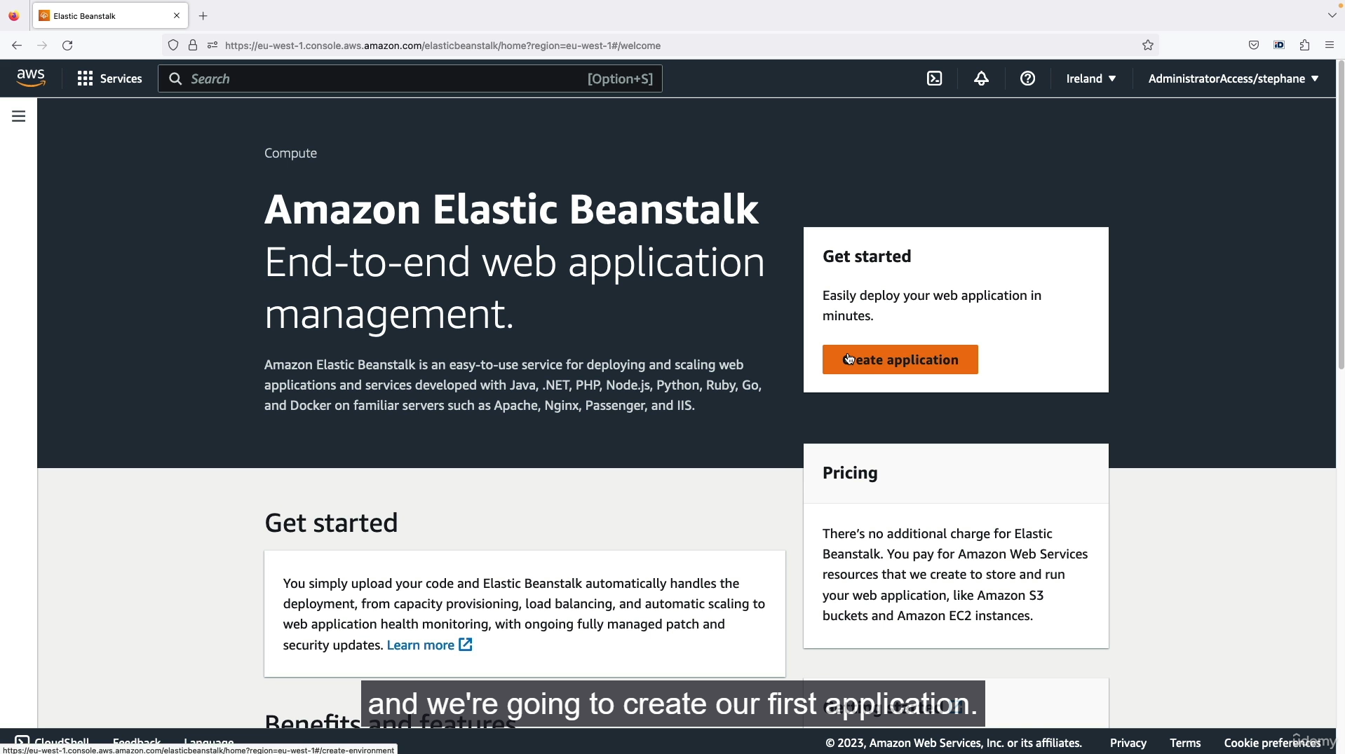

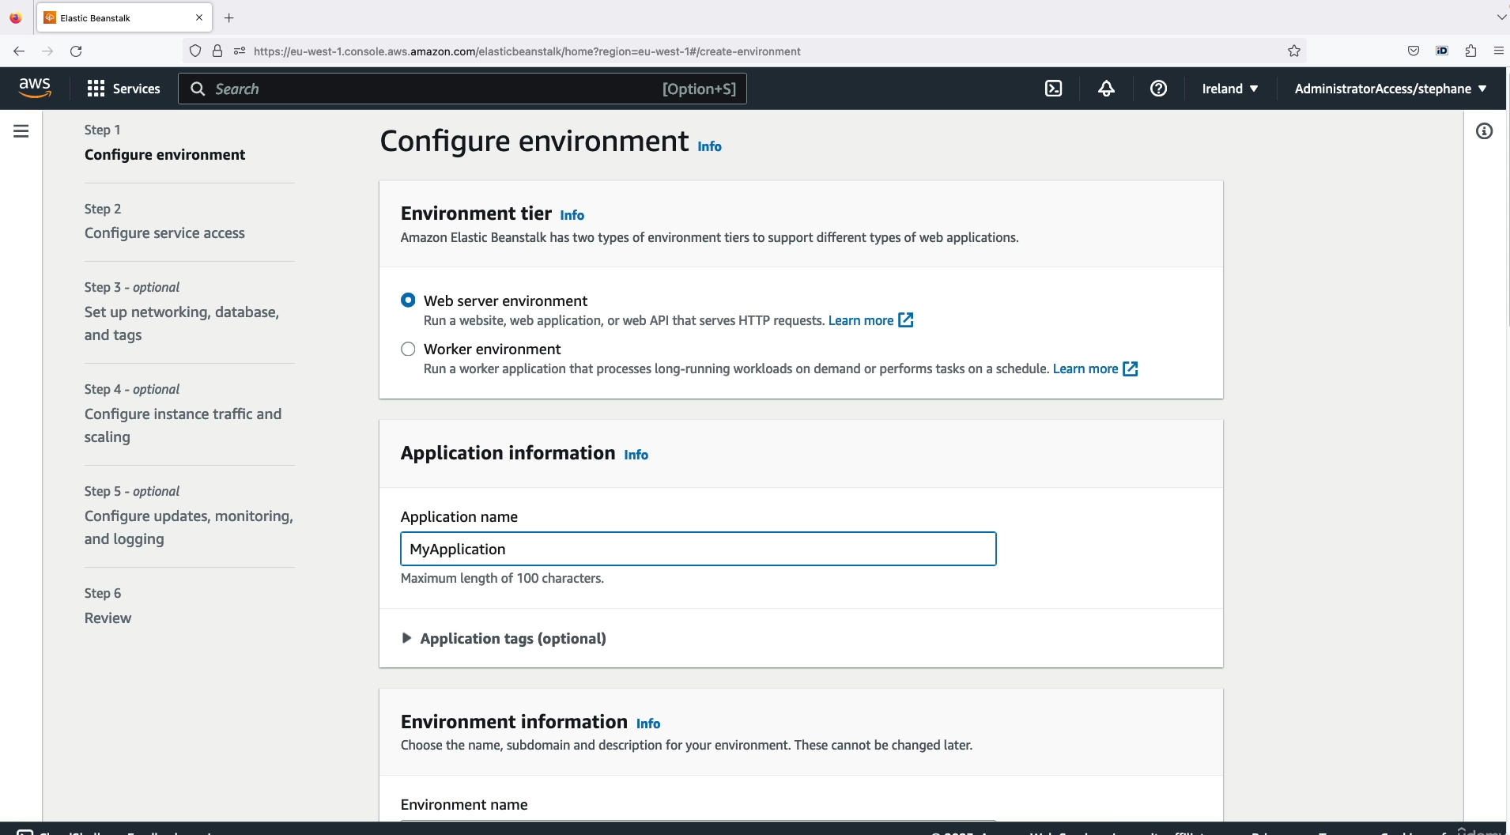

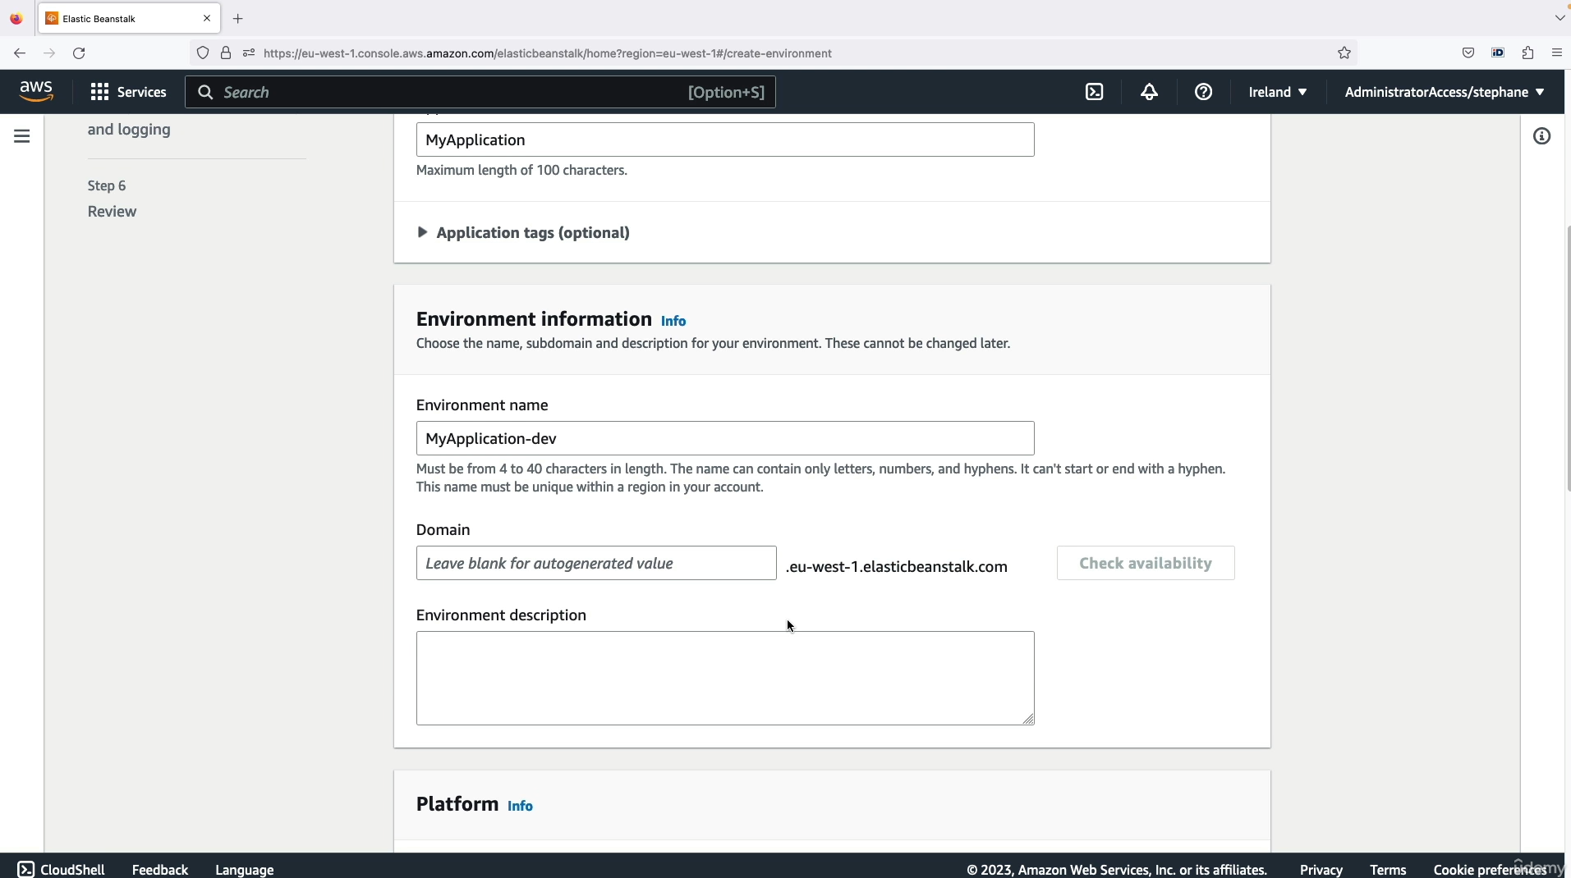

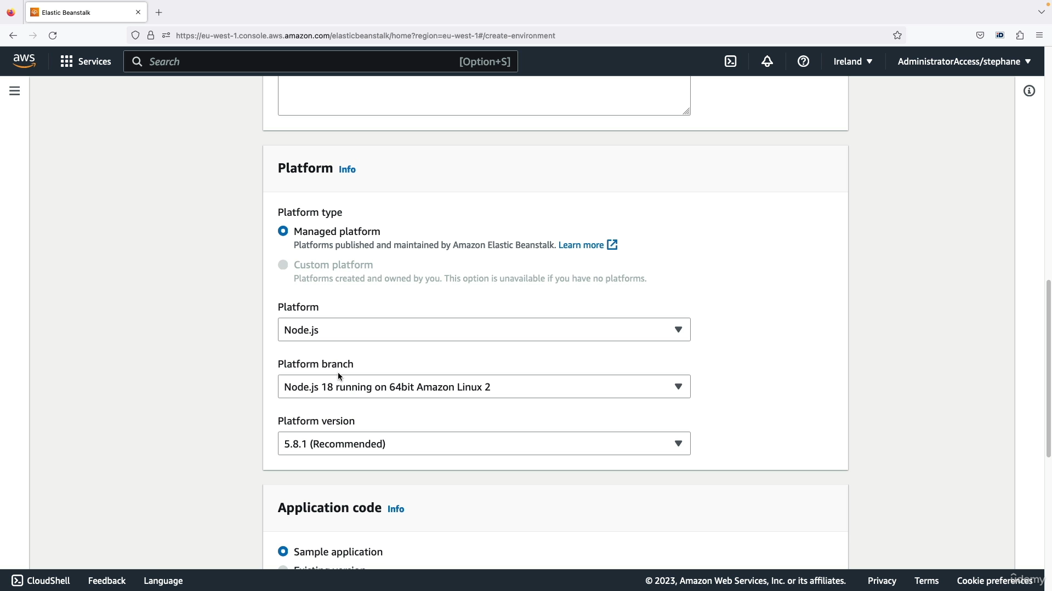

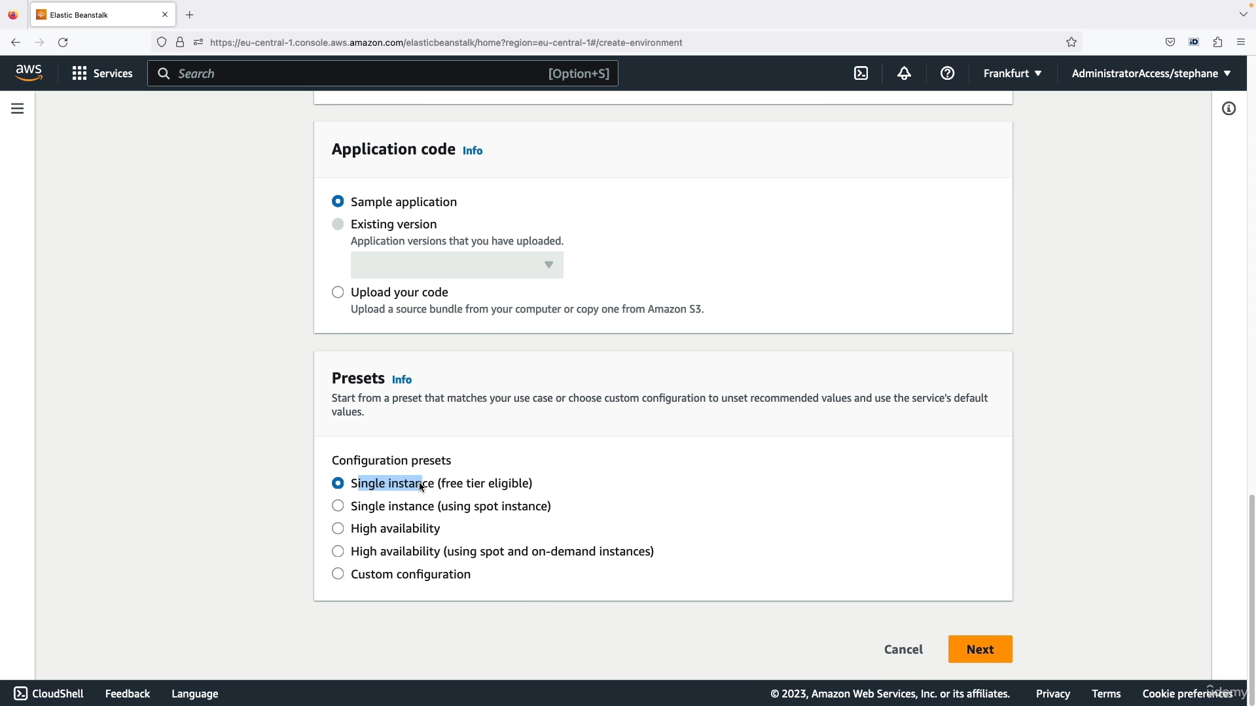

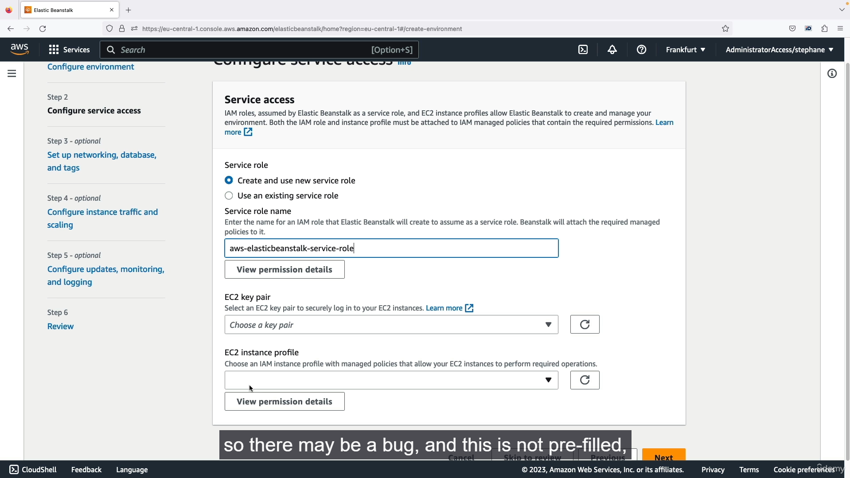

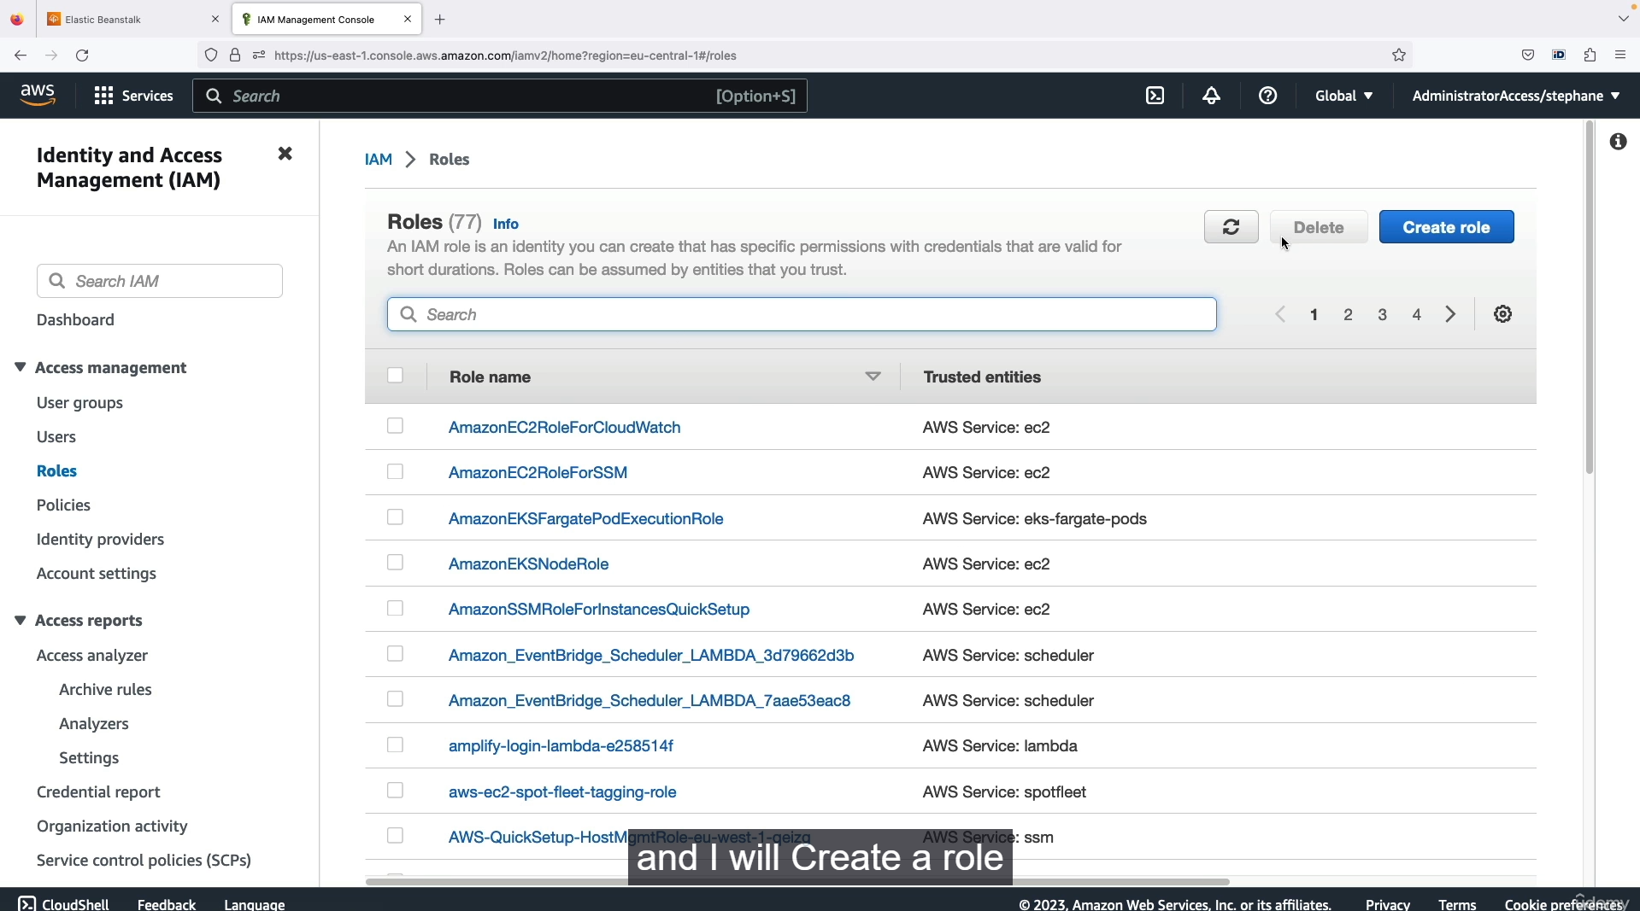

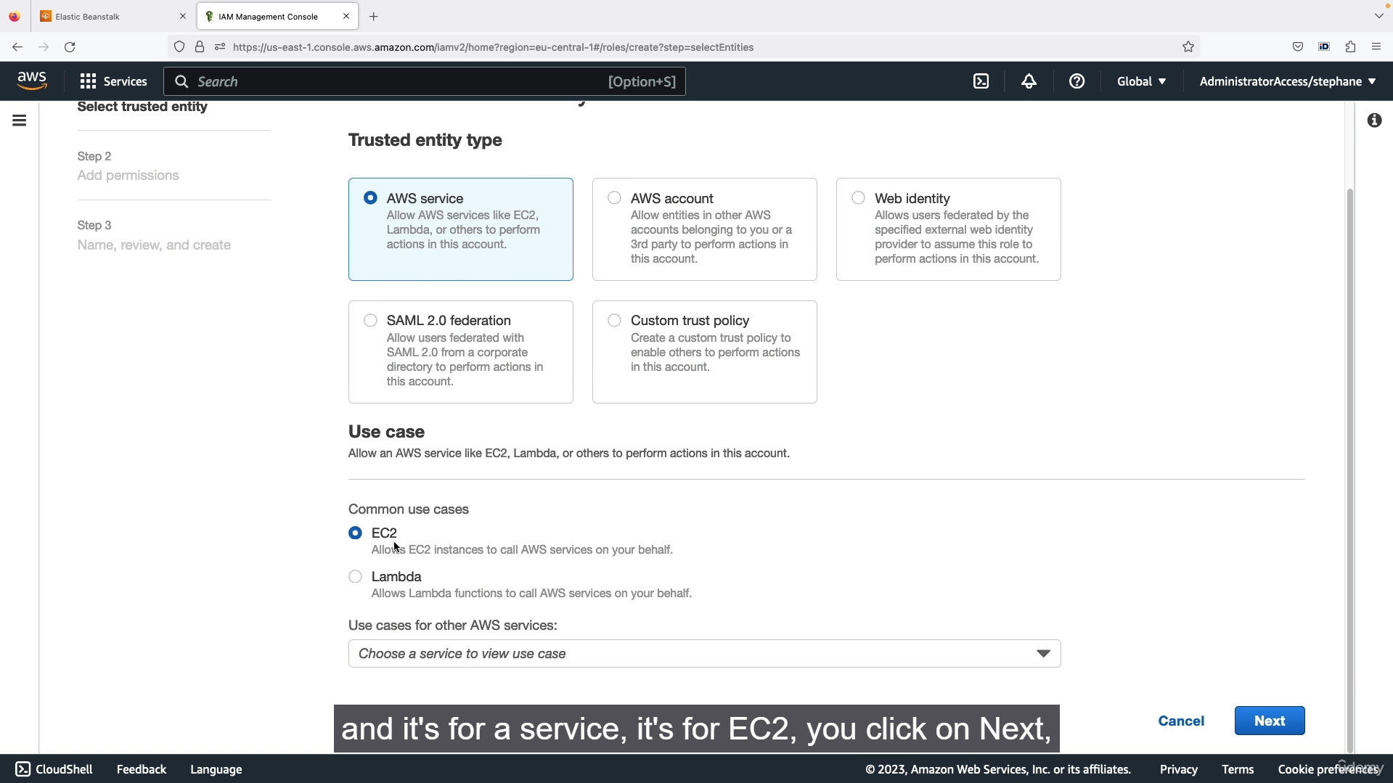

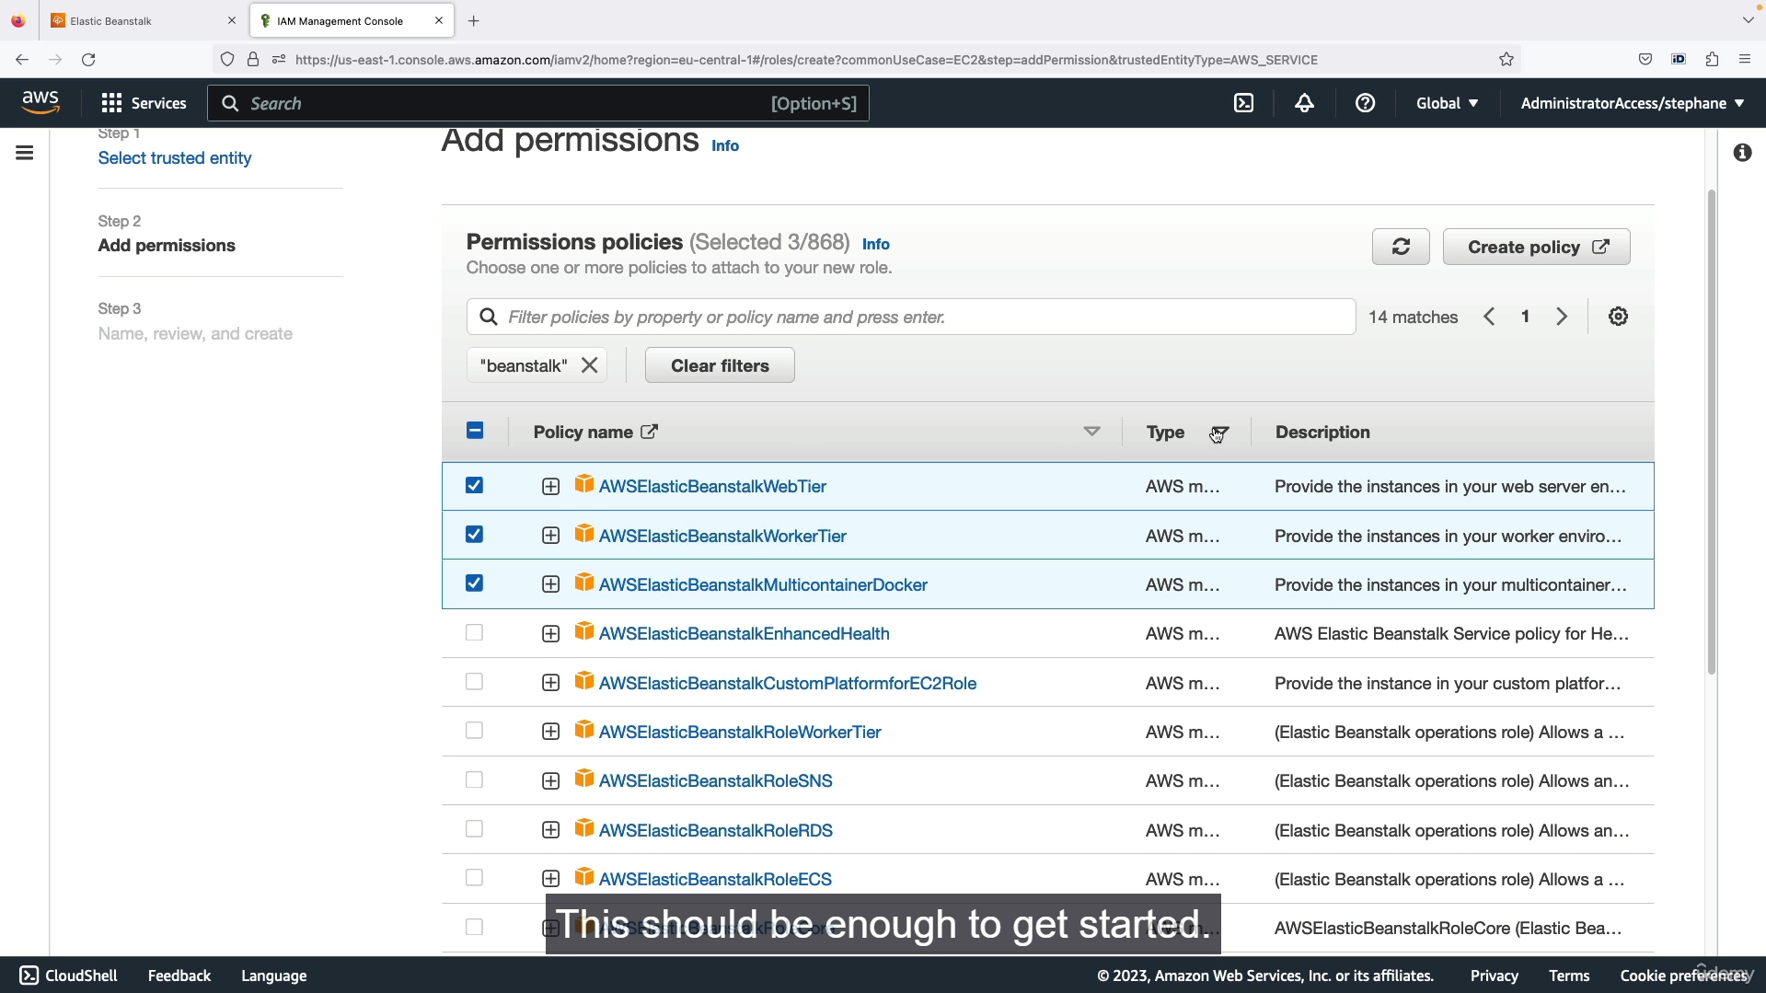

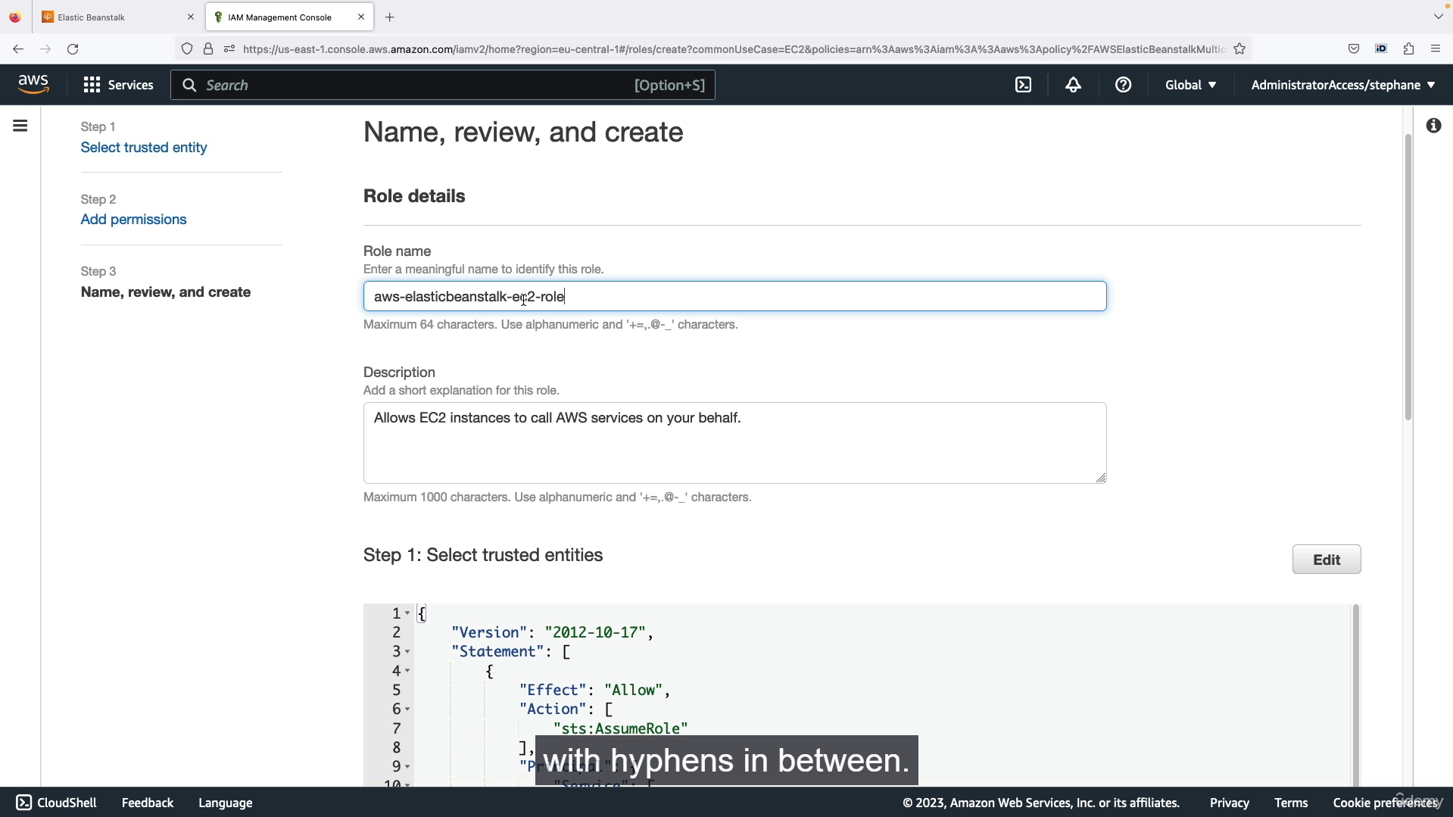

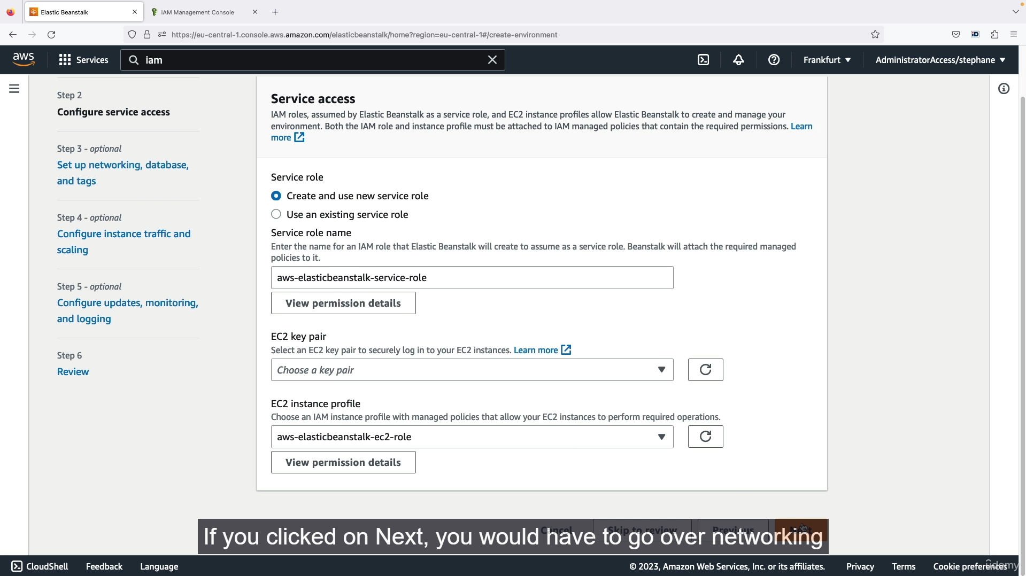

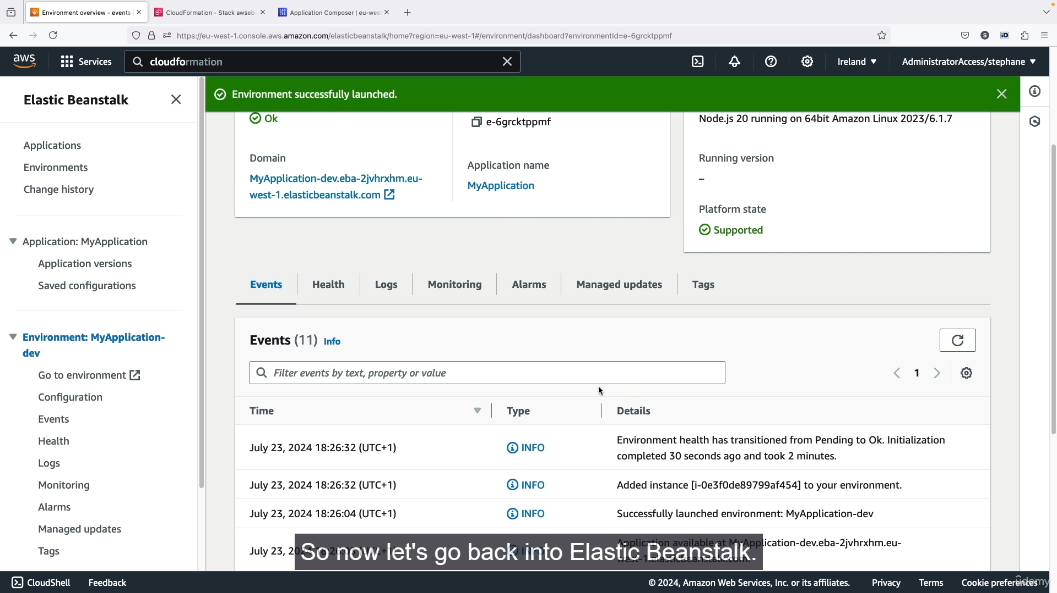

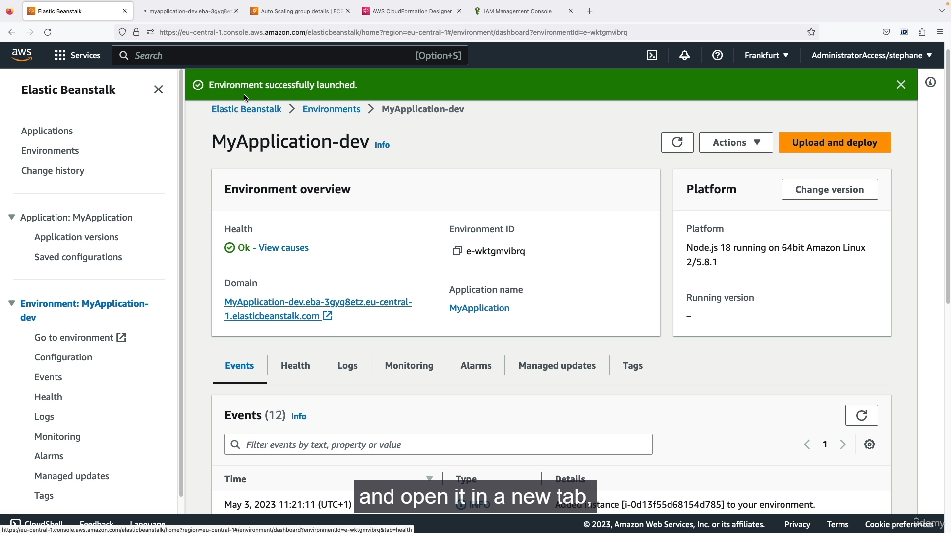

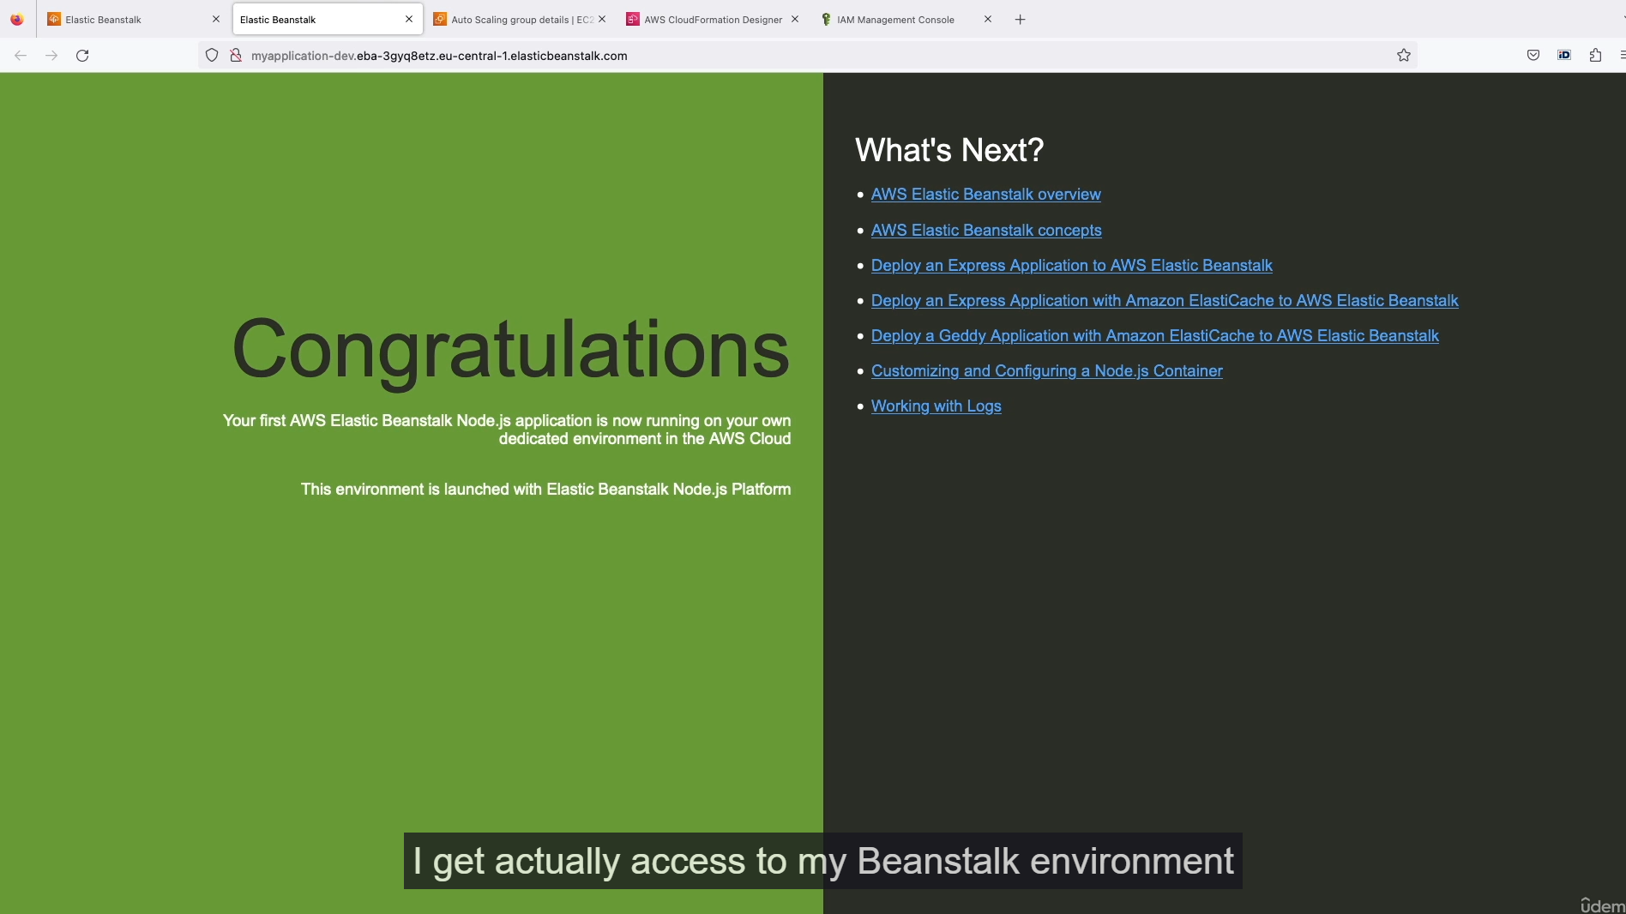

This is a step-by-step guide on how to create a basic web application using AWS Elastic Beanstalk and what's happening behind the scenes.

**1. Creating the Elastic Beanstalk Application**

1. **Navigate to Elastic Beanstalk:** Go to the AWS Elastic Beanstalk console.
2. **Choose Environment Type:** Select **"Web server environment"** to host a website. (The "Worker environment" is used for processing background tasks from a queue).
3. **Application and Environment Naming:**
   * Name your application (e.g., MyApplication).
   * Name your environment (e.g., MyApplication-dev). A domain name will be automatically generated for it.
4. **Select Platform:**
   * Choose a managed platform (e.g., **Node.js**). Use the latest default version.
5. **Choose Application Code:** Select **"Sample application"** for this demonstration.
6. **Preset Configuration:** Choose **"Single instance"** which is eligible for the AWS free tier. (Other options include "High availability" for production environments).

**2. Configuring IAM Roles (Important)**

Due to recent AWS console changes, you might need to manually create the EC2 Instance Profile.

1. **Create IAM Role:**
   * Open the IAM console in a new tab.
   * Go to **Roles** and click **"Create role"**.
   * Select **"AWS service"** for the trusted entity and **"EC2"** for the use case.
2. **Attach Permissions:**
   * Search for "beanstalk" and attach the following managed policies:
     + AWSElasticBeanstalkWebTier
     + AWSElasticBeanstalkWorkerTier
     + AWSElasticBeanstalkMulticontainerDocker
3. **Name the Role:**
   * Name the role aws-elasticbeanstalk-ec2-role.
   * Click "Create role."
4. **Assign Role in Beanstalk:**
   * Go back to the Elastic Beanstalk environment creation page.
   * Click the refresh button next to **"EC2 instance profile"**.
   * The aws-elasticbeanstalk-ec2-role should now be pre-filled and selected.

**3. Review and Launch**

1. **Review and Submit:** Click **"Skip to review"** to use the default settings for your single instance.
2. **Submit:** Confirm the details and click "Submit."

**4. Verification and Behind-the-Scenes Actions**

* **CloudFormation:** Elastic Beanstalk uses CloudFormation behind the scenes to provision all the necessary resources. You can see the events and resources being created in the CloudFormation console.
* **Infrastructure Components:** Beanstalk automatically creates the following for your application:
  + An **Auto Scaling Group** that manages a single **EC2 instance**.
  + A **Security Group** to control traffic to the instance.
  + An **Elastic IP** assigned to the instance.
* **Application Access:** Once the environment's health status is "Ok," you can click the automatically generated domain name at the top of the Beanstalk dashboard to access your running sample application.
* **Environment-Centric View:** Beanstalk provides a centralized dashboard to monitor health, view logs, and check metrics (CPU utilization, etc.) for your application. This contrasts with CloudFormation's focus on arbitrary infrastructure.

**5. Cleanup**

* To avoid incurring costs, it is crucial to delete your application once you are finished.
* From the Elastic Beanstalk console, select your application, go to **Actions**, and click **"Delete application."** This will automatically terminate all associated resources (EC2 instance, Elastic IP, etc.) created by the stack.